# Lab Test Screenshots – brob574

Beginning

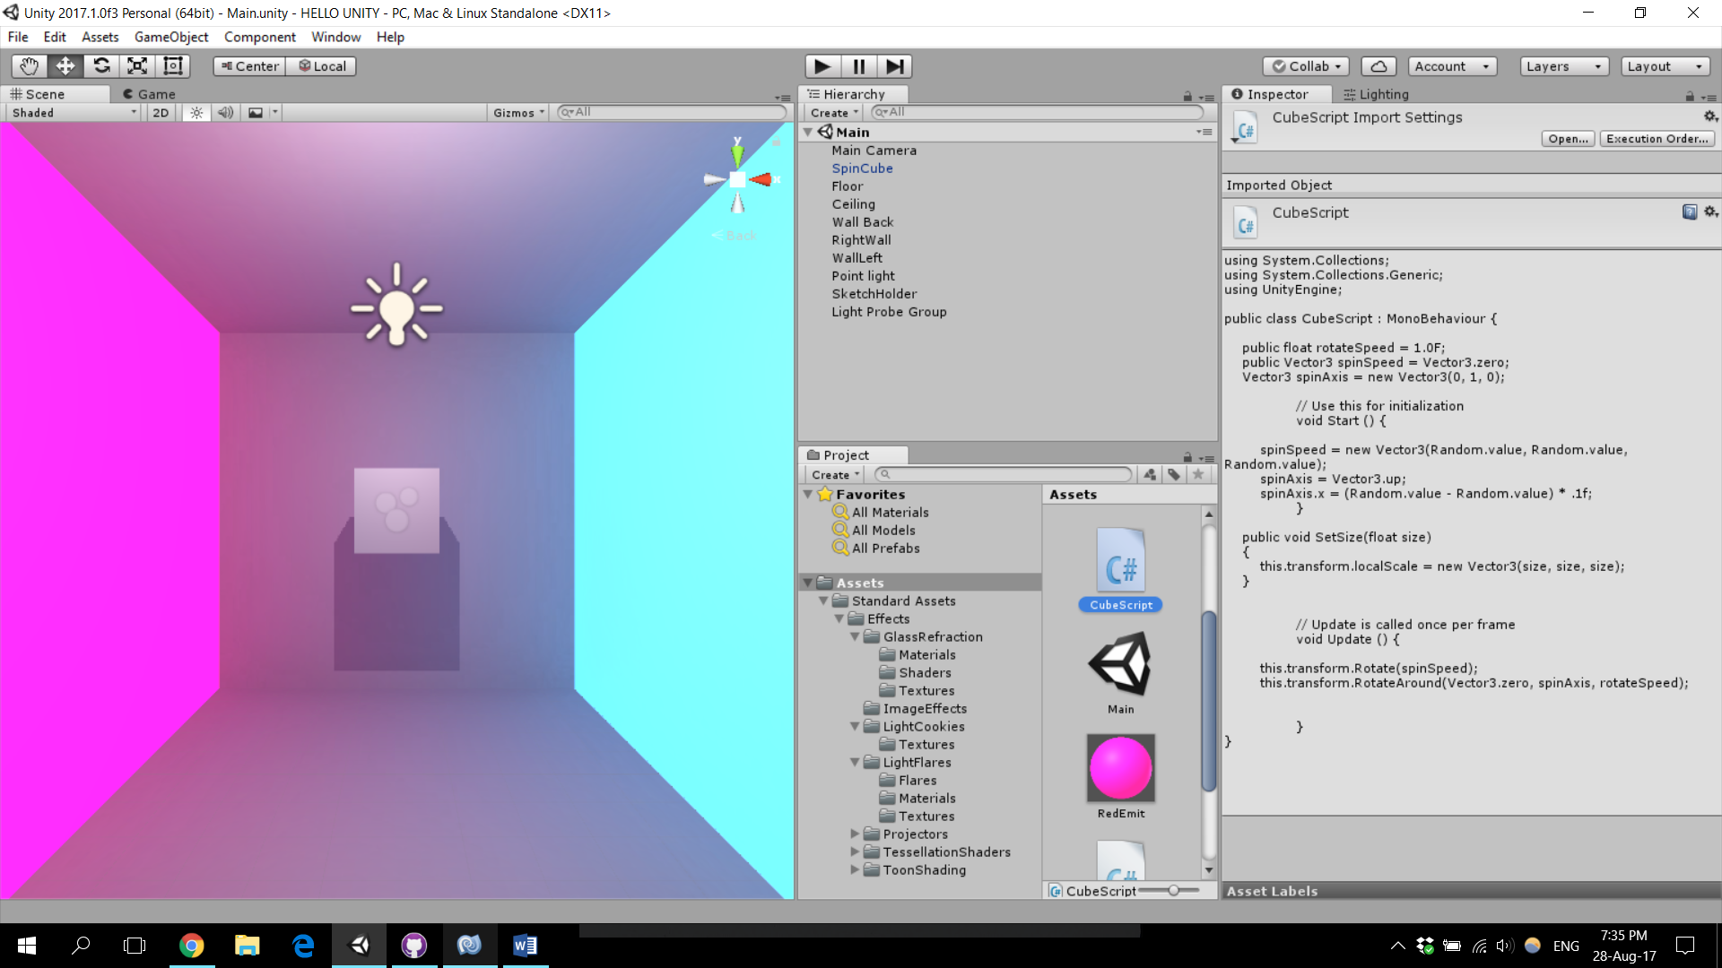

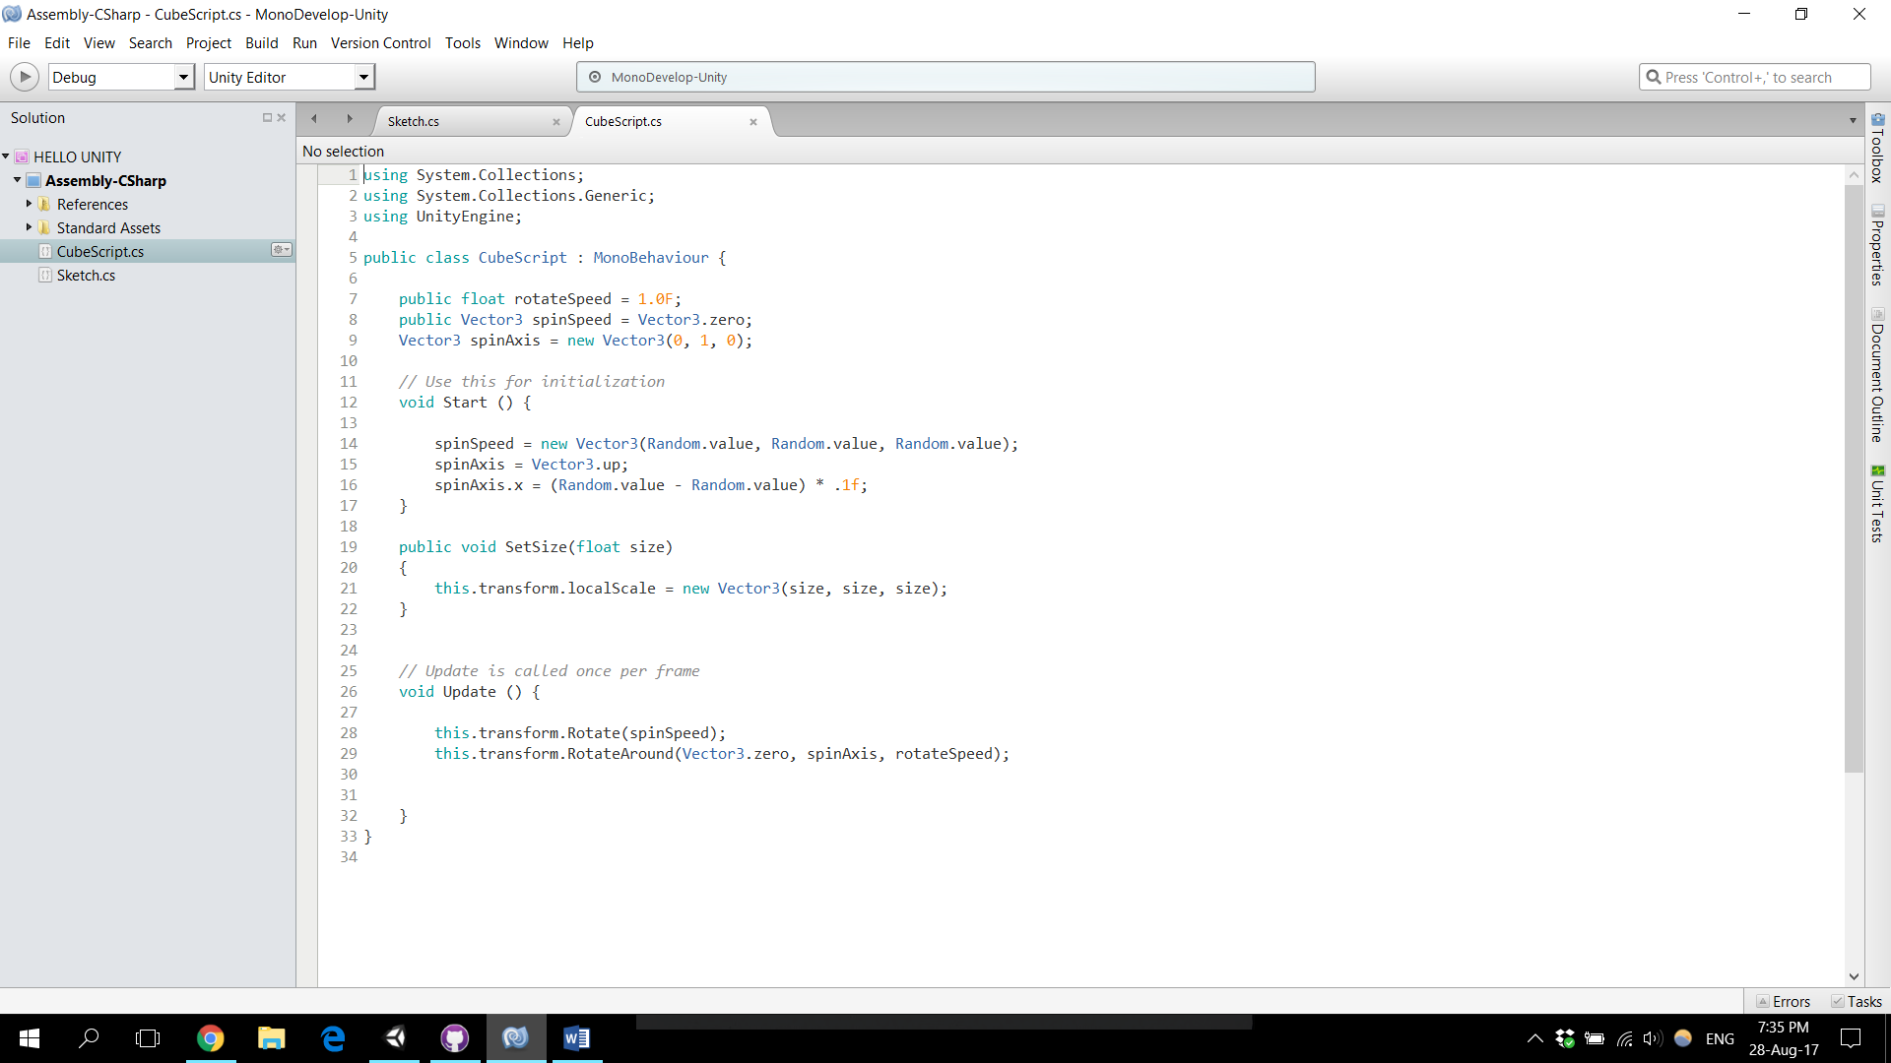

## Q.4

## Q.5

## Q.6